Tarea 1 - "The Mystery Route"

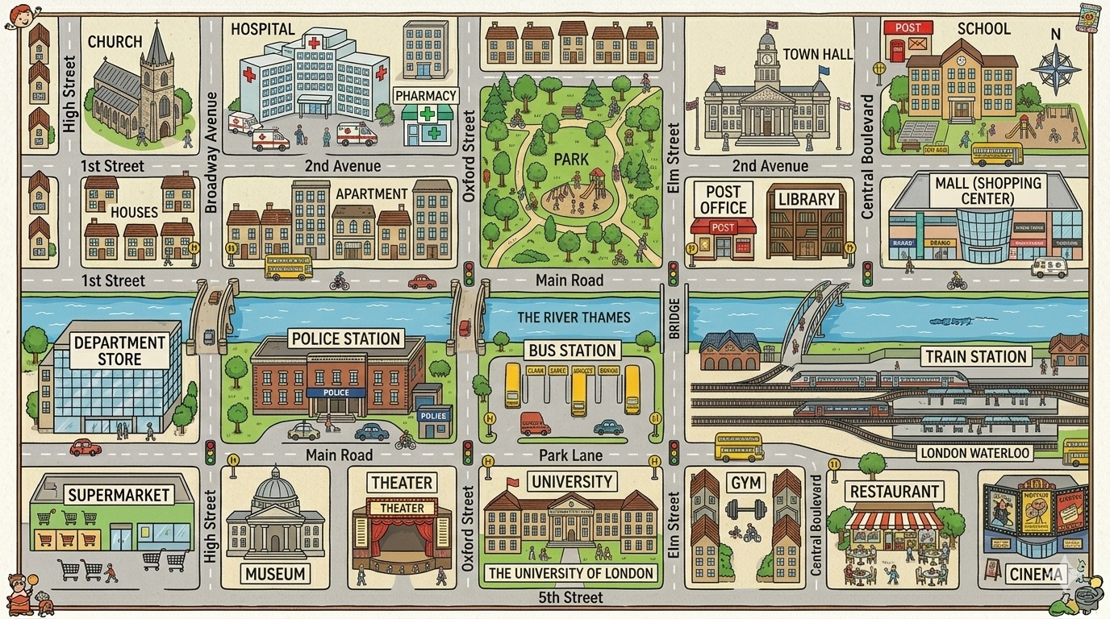
Instructions: Start at the point indicated in each route. Follow the directions carefully and write the name of the final destination.
- Route 1 (Start: SCHOOL): Exit the School and go straight on Central Boulevard. Go past the Mall. At the corner, turn right on Main Road. Cross the bridge over the river. Go straight on and turn left at Elm Street. It is next to the Gym. Destination 1: ___________
- Route 2 (Start: CHURCH): Exit the Church and go straight on High Street. Turn left on 1st Street and turn right on Broadway Avenue. Cross the bridge. Go straight on and turn left on Main Road. It is the building between the Museum and the Theater. Destination 2: ___________
- Route 3 (Start: UNIVERSITY): Exit the University on Oxford Street and go straight on towards the river. Cross the bridge to Main Road. Turn left and go straight on. At the corner of Broadway Avenue, turn right. The building is on your right, opposite the Church. Destination 3: ___________
- Route 4 (Start: TRAIN STATION): Exit the station on Central Boulevard and go straight on. Turn left on 2nd Avenue. Go past the Library and the Post Office. Turn right on Elm Street. At the corner of the Park, turn left on Main Road. The building is opposite the Park. Destination 4: ___________
- Route 5 (Start: BUS STATION): Exit the Bus Station on Oxford Street. Turn right and go straight on Main Road. Go past the Bridge. Turn right on Central Boulevard. Go straight on and go past the Mall. The building is on the corner of 2nd Avenue, next to the Mall. Destination 5: ___________

